TASK -III

1. package oops;  
public class Book{  
 private int bookID;  
 private String title;  
 private String author;  
 private boolean isAvailable;  
  
 public Book(int bookID, String title, String author, boolean isAvailable) {  
  
 this.bookID = bookID;  
 this.title = title;  
 this.author = author;  
 this.isAvailable = isAvailable;  
 }  
 public void setBookID(int bookID){  
 this.bookID = bookID;  
  
 }  
  
 public void setTitle(String title) {  
 this.title = title;  
 }  
  
 public void setAuthor(String author) {  
 this.author = author;  
 }  
  
 public void setAvailable(boolean available) {  
 isAvailable = available;  
 }  
  
 public int getBookID() {  
 return bookID;  
 }  
  
 public String getTitle() {  
 return title;  
 }  
  
 public String getAuthor() {  
 return author;  
 }  
  
 public boolean isAvailable() {  
 return isAvailable;  
 }  
  
 public String toString(){  
 return "BOOKID :"+ bookID +"\n title: "+title+" \nauthor: "+author+"\n Available "+isAvailable ;  
 }  
  
  
  
}  
class Library{  
 Book []books;  
 private int count = 0;  
  
 public Library(){  
 books = new Book[5];  
 count = 0;  
  
 }  
  
 public void addBook(Book book) {  
 if (count < books.length) {  
 books[count] = book;  
 count++;  
 System.*out*.println("the books added successfully");  
  
 } else {  
 System.*out*.println("There is no space for adding books");  
 }  
 }  
  
 public void replaceBook(int bookID,int newBookID,String newAuthor,String newTitle){  
 for(int i = 0; i < count;i++){  
 if(books[i].getBookID() == bookID){  
 books[i].setBookID(newBookID);  
 books[i].setTitle(newTitle);  
 books[i].setAuthor(newAuthor);  
 System.*out*.println("The book replaced");  
 return ;  
 }  
  
 }  
 System.*out*.println("The book"+ bookID +"not found");  
 }  
  
 public void display(){  
 if(count == 0){  
 System.*out*.println("there is no book in library");  
 }  
 else {  
 for (int i = 0; i < count; i++) {  
 System.*out*.println(books[i]);  
 }  
 }  
 }  
  
 public Book searchByBookId(int bookID){  
 for(int i = 0; i < count ;i++){  
 if(books[i].getBookID() == bookID){  
 return books[i];  
 }  
 }  
 return null;  
 }  
  
  
}

package oops;  
public class Book{  
 private int bookID;  
 private String title;  
 private String author;  
 private boolean isAvailable;  
  
 public Book(int bookID, String title, String author, boolean isAvailable) {  
  
 this.bookID = bookID;  
 this.title = title;  
 this.author = author;  
 this.isAvailable = isAvailable;  
 }  
 public void setBookID(int bookID){  
 this.bookID = bookID;  
  
 }  
  
 public void setTitle(String title) {  
 this.title = title;  
 }  
  
 public void setAuthor(String author) {  
 this.author = author;  
 }  
  
 public void setAvailable(boolean available) {  
 isAvailable = available;  
 }  
  
 public int getBookID() {  
 return bookID;  
 }  
  
 public String getTitle() {  
 return title;  
 }  
  
 public String getAuthor() {  
 return author;  
 }  
  
 public boolean isAvailable() {  
 return isAvailable;  
 }  
  
 public String toString(){  
 return "BOOKID :"+ bookID +"\n title: "+title+" \nauthor: "+author+"\n Available "+isAvailable ;  
 }  
  
  
  
}  
class Library{  
 Book []books;  
 private int count = 0;  
  
 public Library(){  
 books = new Book[5];  
 count = 0;  
  
 }  
  
 public void addBook(Book book) {  
 if (count < books.length) {  
 books[count] = book;  
 count++;  
 System.*out*.println("the books added successfully");  
  
 } else {  
 System.*out*.println("There is no space for adding books");  
 }  
 }  
  
 public void replaceBook(int bookID,int newBookID,String newAuthor,String newTitle){  
 for(int i = 0; i < count;i++){  
 if(books[i].getBookID() == bookID){  
 books[i].setBookID(newBookID);  
 books[i].setTitle(newTitle);  
 books[i].setAuthor(newAuthor);  
 System.*out*.println("The book replaced");  
 return ;  
 }  
  
 }  
 System.*out*.println("The book"+ bookID +"not found");  
 }  
  
 public void display(){  
 if(count == 0){  
 System.*out*.println("there is no book in library");  
 }  
 else {  
 for (int i = 0; i < count; i++) {  
 System.*out*.println(books[i]);  
 }  
 }  
 }  
  
 public Book searchByBookId(int bookID){  
 for(int i = 0; i < count ;i++){  
 if(books[i].getBookID() == bookID){  
 return books[i];  
 }  
 }  
 return null;  
 }  
  
  
}

OUTPUT:

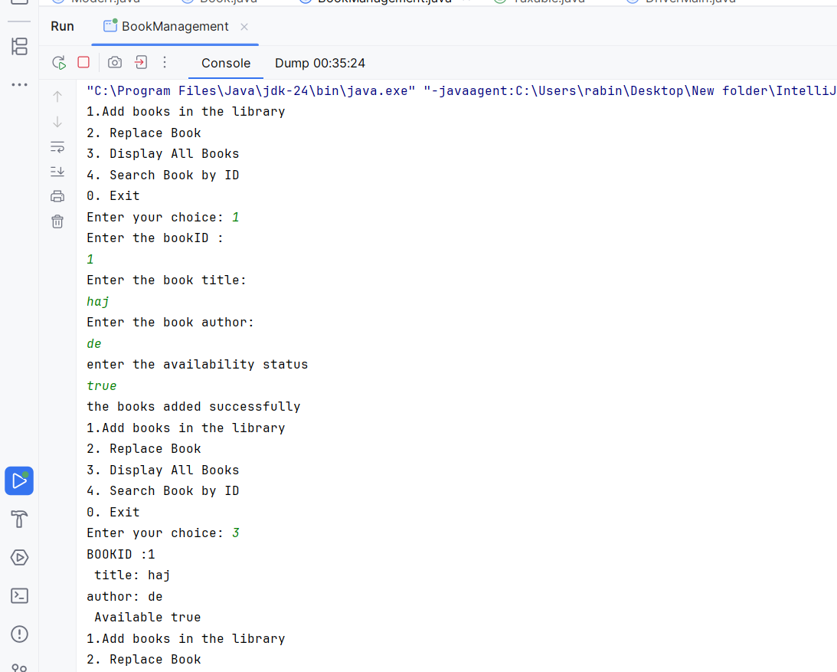

2.

package oops;  
  
public interface Taxable {  
 double *salesTax* = 0.07;  
 double *incomeTax* = 0.105;  
  
 public double calcTax();  
  
}  
class Employee implements Taxable{  
 int empId;  
 String name;  
 double salary;  
  
 public Employee(int empId,String name,double salary){  
 this.empId = empId;  
 this.name = name;  
 this.salary = salary;  
  
 }  
 public double calcTax(){  
 double yearly = salary \* 12;  
 double tax = yearly - (yearly \* *incomeTax*);  
 return tax;  
 }  
}  
class Product implements Taxable{  
 int pid;  
 double price;  
 int quantity;  
  
 public Product(int pid, double price, int quantity) {  
 this.pid = pid;  
 this.price = price;  
 this.quantity = quantity;  
 }  
  
 public double calcTax(){  
 double tax =price - (price \* *salesTax*);  
 return tax;  
 }  
  
}package oops;  
import java.util.\*;  
public class DriverMain {  
 public static void main(String[] args){  
 Scanner scanner = new Scanner(System.*in*);  
 System.*out*.println("Enter Employee Details:");  
 System.*out*.print("ID: ");  
 int empId = scanner.nextInt();  
 scanner.nextLine(); *// consume newline* System.*out*.print("Name: ");  
 String name = scanner.nextLine();  
 System.*out*.print("Monthly Salary: ");  
 double salary = scanner.nextDouble();  
  
 Employee emp = new Employee(empId, name, salary);  
 double result1 = emp.calcTax();  
 System.*out*.println(result1);  
 *// Input for Product* System.*out*.println("\nEnter Product Details:");  
 System.*out*.print("Product ID: ");  
 int pid = scanner.nextInt();  
 System.*out*.print("Price: ");  
 double price = scanner.nextDouble();  
 System.*out*.print("Quantity: ");  
 int quantity = scanner.nextInt();  
  
 Product prod = new Product(pid, price, quantity);  
 double result2=prod.calcTax();  
 System.*out*.println(result2);  
 }  
}

OUTPUT:

